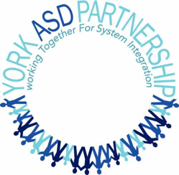
Medical Appointments – Additional Resources

“Caring for Your Patient with ASD” and “My Medical Appointment” are resources developed by the York ASD Partnership to assist individuals with ASD and their families/caregivers in accessing the best health care possible by providing health care professionals with clear, specific and relevant information. If those resources do not meet your needs or if you require additional assistance, the resources listed below may help.

CanChild MyTransition
https://www.canchild.ca/en/research-in-practice/current-studies/apply-the-mytransition-app-in-transition-applyit-study/mytransition-app

H-CARDD Website
https://www.porticonetwork.ca/web/hcardd (with links to items 3, 4, 5, 6, 7 below)

About My Health
https://ddprimarycare.surreyplace.ca/wp-content/uploads/2021/03/5.1-About-My-Health-new.pdf

My Healthcare Visit
http://ddprimarycare.surreyplace.ca/wp-content/uploads/2019/08/5.2-My-Healthcare-Visit.pdf

About Me
https://www.porticonetwork.ca/documents/38160/99698/About+Me_YM_Oct14_rotated.pdf/f2f436ee-63ec-4e76-ab10-c5924de5bc75

Seizure Action Plan
https://ddprimarycare.surreyplace.ca/wp-content/uploads/2019/06/3.7.2-Seizures-Action-Plan.pdf

Developmental Disabilities Primary Care Guidelines
https://apps.apple.com/ca/app/developmental-disabilities/id1517334408

ConnectAbility “Health and Wellness” section
https://connectability.ca/2011/09/19/health-and-wellness-2/

